**Issue 9**: “Make this default address” checkbox is not present

**Description**: It would be good to have the checkbox,” Make this default address”. So the returning customers don’t need to provide the address again.

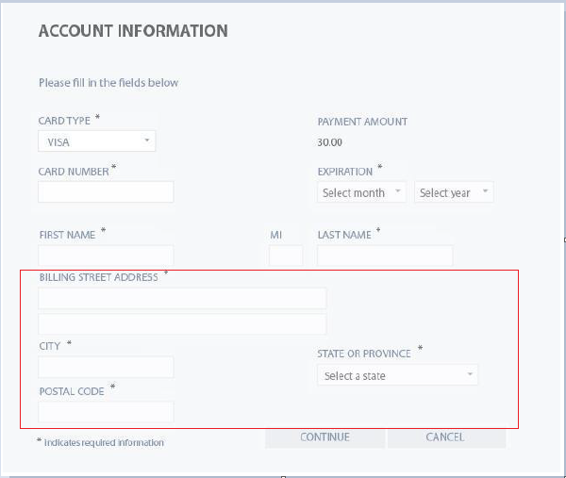

**Expected Behavior**: “Make this default address” checkbox should be present

**Severity**: Minor